**CHAPTER ONE**

1. **INTRODUCTION**

Man in search of comfort ability struggle to meet up with good career and for this to be achieved, it has to be started as early as possible. From time man is born, he is been studied to know what likely he will be able to do as he grows up. This has to do with his natural behaviour and mental exercise display. This continues in family parents and other relaxation acting as counselling unit until the child goes in to school. In school the teacher takes over the counselling, it is a continuous exercise until one finds his feet, then he can continues from there and equally be in a position to guide and counsel others.

Harthony (1990) stated that communication system carries a mixture of voice, data and image signals that are used effectively as intelligent rods in communication system acting as switches, multiplexes, demultiplexens protocol converters.

Olorunsola and Ekong (2006) emphasized that the importance of computers in the exchange of electronic mail (e-mail) with other users, transfer of public domain software from another computer into another disk so that anybody can run the programme on the computer and hold conference with a number of other users. This is one of the major applications of computers in communication. The introduction of office automation and information technology has assisted to strengthen information and service delivery.

According to Bhuiyan (2011) major computerization and infrastructure development in the public sector in Bangladesh has been taking place to replace internal manual work processes by ICT-based automation. Similarly, the impact of computer education on the efficiency of civil services Nigeria cannot be over-emphasized. The civil servants need to be educated in ICT, so that the use of typewriters, filling of information on papers in cabinets, keeping of documents and letters in files are modernized through automation.

The stages where much work is carried out on counselling is in secondary schools .This is a stage when a child is grown to be able to understand maturely and when the child’s attitude is fully studied in line with academic performance . In all secondary school across the country, there exist a guidance and counsellor office where people knowledgeable in the area of psychology are employed in order to help advise the younger ones in school which way forward to their future career. There people through class visitation, Observing students during recreation and calling on them at intervals for questioning, came to know the students betters and be able to guide and counsel them in their future career probably in university or in any other area of endeavour.

The job of counselling in secondary school is not an easy job to be taking into consideration the number students involved with respect to the number of staff involved. It is always very difficult to handle all the students and to remember everything about the students. This Counselling exercise needs a sophisticated system for the operation of counselling alliterates some of the problem associated with exercise.

Personal behaviour and area of interest, they keep very close marks with the students to make sure that no stone is left unturned. This aspect of ones life is taken very seriously in schools because that is mainly the reason people go to school for the academics tests and examination only. The battle of career choice is handed over to individual when he/she attain a stage of being able to duct for himself what he/she really wants and how best possible to get such height. The person can steer the wheels directly to his destination or deviate in the other way due to carelessness or youthful exuberance; but the end justifies the means. Also, sometime due to laxity and incapability on the side of the career guidance and counsellor in schools, most of the students are led astray. This is mainly due to human approach towards the implementation the exercise which can be based at anytime. In his own recommendation, Hook advised the computerization of the career guidance department for effectives and reliable react on the department activities.

Holyfield (1997) argues that a good career in life, makes a lot of meaningful process in life. He made this assertion that what without comfort and where is comfort without a good career; In his own views, it takes a long and rough way to arrive and clinch a good career but when one finally gets to it, life comes to be what nature made it be, life remains unstable like a wondering man in the career is achieved through carefulness and hard work, desire of sentiments and other side effects which can thwart the smooth direction of ones futures. Holly field (1997) made it clear and that life is associated with a good career and that such a career is what can give full meaning of life a priceless gift of nature.

Statistics shows that people who find good career are enjoying high standard of living and while the people who find good career are enjoying, the unlucky ones cry of frustration and negatives social factors that limits life.

* 1. **Background Of The Study**

The Hong Kong Association of career master and guidance master with the support of life learning library section ,curriculum development institute, education bureau has the privilege to prepare students for secondary school( Senior class) from a career development perspective, based on extensive review on theoretical material and empirical evidence, the project provides a substantial argument on reason of developing computerised career information management system and it’s integral role school in secondary school curriculum.

Systematic analysis of the project in secondary school is reviewed, followed by recommendation for student in response to their strengths and weakness been identified.

**1.2 Statement Of The Problem**

There is significant increase in the number of students that needs the attention of counsellor in our secondary schools, while counselling staff are few.

Another major problem of the counselling is information storage. The storage of information observed from the students in different forms is not reliable and this makes the counselling to apply guess work in trying to direct students in their future career work. This is a very big delay in taking decision on students concerning their future career. This is also because referencing to students information for decision making takes a very long time. Hence, a Computerized Career Guidance Information Management System capable of guiding and directing secondary school student on their career chosen in the absence of a counsellor was designed, implemented and executed in the project work.

**1.3 Aim/Objectives**

The aim of this project is to design and implementation of Computerised Career Guidance Management Information system for senior secondary schools peoples from JSS3 to SSS3.The objectives of the study include the following:

1. To develop a system that will give detailed information of the students such as basic information, educational background and parent’s information.
2. To design a career guidance system that incorporate Career Guidance and Personality Tests for secondary school students.
3. To maintain adequate observed information on students for future reference and quick decision making.

**1.4 Significance Of Study**

This study is of numerous important to the guidance and counsellor department and the society in general. It will help the counsellor to always direct the students in their best career area with happiness because it will be result oriented.

It will help to eliminate the word frustration among the people which is very common in the society.

**1.5 Scope Of The Study**

The study covers the design and implementation of computerized career choice counselling system in secondary schools.

**1.6 Research Methodology**

The methods used in carrying out this project work are as follows:

1. A well designed computer career guidance management information system using suitable design tools.
2. The implementation of the designed system in (i) using query language (Ms Access) to create the data base and C#.Net to generate the interface of the system.
3. Information related to career counselling are gathered by serving questionnaire to secondary school students.
4. Evaluation of the performance of the newly developed system on computer system.

**1.7 Definition Of Terms**

**Counselling:** To give advice to another

**Society:** This is an organized group of people living together and having things together

**Automatic**: Work in faster rate without much human direction

**Prompt:** To motivate an action

**Recreation**: Time that are not invested in working , time used for relaxing

**Alleviate**: To reduce or less something

**Sophisticated:** Showing great experience

**System:**  A group of thing or parts working together to achieve a purpose

**Psychology:** The study of mind and its function

**Data:** This is a raw and unprocessed facts used in deciding or discussing something

**Record**: to write down event so that it can be remember d

**Computer**: This is electronic devices that accept raw facts as data and processes it to give useful information.

**Information:** This is a raw fact that has undergone processing.

**Computerized:** To control, perform, process, or store (a system, operation, or information) by means of or in an electronic computer or computers.

**CHAPTER TWO**

**2.0 LITERATURE REVIEW**

**2.1 General Overview**

According to Watts and Fretwell (2004), career guidance and orientation services have been defined as services intended to assist individuals of any age and at any point throughout their lives, empowering them to make educational, training and occupational choices and to manage their careers.

They include three main elements:

1. Career Information
2. Career Counselling, and
3. Career education (Watts & Fretwell, 2004, p.2).

Career guidance in schools usually focuses on career information that provides information on courses, occupations and career paths. It also includes labour market information. The aim of Career counselling in schools is to hold one-on-one or small group interviews focused on the distinctive career issues faced by individuals, such as career in education. Being part of the educational curriculum, attention is paid to help groups of individuals to develop their competence to manage their career development. The role of Career Guidance is not only limited to education process but it also affects the national social and economic development. According to Watts (1977), formal Career guidance services are derived from economic and social development, playing a crucial role in helping to coordinate the education system and the labor market, in order to realize their goals successfully. Generally, the aim of career guidance is to help students make decisions based on their interests, passion and abilities, while taking into account current and future career opportunities. Students are encouraged to learn more about the world of employment across different industries, so that they may take right steps to obtain their objectives, goals and aspirations (MoE, Singapore). Another perspective indicated that career guidance can be referred to as services and activities intended to assist individuals of any age and at any point throughout their lives, to make educational, training and occupational choices and to manage their career (OECD, 2004). “Career guidance” denotes systematic programs that facilitate individual career development and career management (Herr & Cramer, 1996).

As discussed above, career guidance renders services and activities that are geared towards helping individuals of any age at any point throughout their lives to make their educational training and occupational choices in order to manage their career OECD (2004).

As it is pointed out by Herr and Cramer (1996), career guidance offers systematic programs that facilitate individual career development and career management. Career guidance is much more than mere face to face interviews: SCAGES (Standing Conference of the Association for Guidance in Education Settings UK 1992) recognized eleven different activities of career guidance, such as informing students about the current and future opportunities of job market advising, assessing, teaching, enabling, advocating, networking, giving feedback, managing and innovation or systems change.

Yet another important role of career guidance in schools is to prepare students for the world of employment by equipping them with the right set of skills, so that they may stay relevant and fit into the global economy while leading a purposeful life. It is revealed by previous research evidence, that education along with career guidance have positive impact on the students’ academic performance and well-being, for they help them make good decisions regarding their education career. Education and career guidance is aimed at such goals as:.

1. Fostering students’ self-awareness, self-directedness as well as skills to determine workable goals, and to learn consistently in order to add value to their future workplace.
2. Assisting students to explore and make decisions based on valid information towards their education and career oriented directions.
3. Instilling in their minds the value of utility for all sort of careers and how all these contribute towards the smooth and healthy functioning of the society; and last but not least.
4. Equipping students with the skills and means by which they may be able to positively engage their parents and other career influencers (MoE, Singapore).

**2.2 The Roles Of Career Guidance In Socio-economic Development.**

It has been highlighted by researchers that career guidance has greatly contributed to national educational and labour market policy goals in terms of raising people’s interest in education and training as well as boosting their participation in formal and non-formal learning, which has positive effects on the overall learning outcomes. It empowers students by equipping them with better decision-making skills and making them well aware of learning opportunities (Killeen, White & Watts, 1992; Rosen, 1995; Watt, 1996).

In addition, it increases job exploration and search activities among jobseekers, thus, it is proven to be helpful in reducing unemployment by informing people to improve their qualification and seek new kinds of jobs in different areas (Bysshe, Hughes & Bowes, 2002).

Furthermore, an American study found that providing comprehensive guidance services to students at schools can have a positive impact on the quality of their educational and professional decisions, and also on their educational performance and the overall climate of the school (Lapan, Gysbers & Sun, 1997).

It Supports Key Policy Objectives Ranging from Lifelong Learning to Social Equity In terms of learning goals, career guidance is important for it supports lifelong learning for both youth and adults and develops human resources to support national and individual economic growth. It also supports the development of a more flexible education and training system, strengthening the linkages between education/training systems and the labour market (Watts & Fretwell, 2004). Many countries across the globe acknowledge the value and importance of career guidance for it effectively supports education systems, establishes good curriculum and enhances the quality of human resources. Yet another important hallmark of career guidance is its role in fostering social equity. In some countries such as Finland, Germany and Norway, It is believed that career guidance is an important agent of the social integration of migrants and ethnic minorities, by bringing harmony between them. It can support the integration of the disadvantaged and the poorly qualified, and in employment it can address the growing polarization of the labor market, enhance the presence of females in the work force and address the issue of gender segregation in the labour market. Educational qualification and employment are important determinants of social mobility, and access to them is a key indicator of social equity (OECD, 2003).

It Builds Human Capital and Employability throughout the Lifetime Career guidance is not limited to providing information about jobs and guidance to students in their decisions, but it also helps the youth in selecting their skills needed for developing and executing their long-term goals as a fundamental element of human capital (Gazier, 1999).

The effectiveness of career guidance in assisting unemployed people requires individual action plans to be constructed, that involve such components as job search, education and training, stressing the ability to find and keep a job, and the personal capacity of adaptation to a changing labour market and the latest job requirements. Career management skills appear to play an important role in the formation and use of human capital and in the development of employability.

**2.2 Career Guidance Approach Around The World**

**2.2.1 Asia**

In Singapore, the Minister for Education, Mr Heng Swee Keat, indicated in 2014, that “Our education system must… nurture Singapore citizens of good character, so that everyone has the moral resolve to withstand an uncertain future, and a strong sense of responsibility to contribute to the success of Singapore and the well-being of fellow Singaporeans.” Education career guidance in Singapore is based on appropriate activities for students from primary to postsecondary school levels. The model shows education and career development as a process that takes place throughout one’s life. It is a framework that guides schools in coming up with a developmental span that contains three progressive phases, namely, career awareness, career exploration and career planning.

The process of discovering one’s identity involves clarification of interests and values, understanding one’s strengths, developing abilities, and formulating life roles in the context of one’s life experiences. All these work towards building social and emotional competencies that help students become proactive, resilient and adaptable. Research by Perry, Liu and Pabian (2010) shows that when students see that there is a relevance between their studies and future career aspirations, they tend to exhibit more involvement and motivation in school. The ECG lessons will provide students with opportunities to explore and investigate various industries, jobs and possible further education options, enabling them to see the relevance between their studies and aspirations.

In secondary school, the phase of education guidance career is to deepen students’ understanding of self and relate schooling to different education and career pathways. Students would (1) explore the world of careers; (2) understand the relevant courses of study; and (3) develop awareness of their skills, interests and values.

The curriculum of career guidance in Singapore is divided in several main themes, including:.

1. Self-awareness and self-management.

2. Awareness of relational support and decision influencers.

3. Exploring the education landscape and planning pathways and

4. Career sectors exploration. It is an important policy goal to deliver the career guidance approach to all students including both individuals and groups.

**2.2.2 AFRICA**

In South Africa, according to Angels (1994: 2) in Zunker (2002) career development is defined as “the total constellation of psychological, sociological, educational, physical, economic, and chance factors that combine to influence the nature and significance of work in the total life span of any given individual”. It reflects individually developed needs and goals associated with stages of life and with tasks that affect career choices and subsequent fulfilment of purpose. Some current literature on career development (Zunker 2002; Stern 2003; Plant 2004; du Toit 2005; Bernes et al. 2007; ) suggest that the career counselling movement is at crossroads, the movement is increasingly challenged to meet the needs of a society that is experiencing vast changes in the workplace and that is rapidly becoming more diverse (Zunker 2002). The life of a typical high school learner is one full of uncertainty and turmoil, it is a time of increasing stress with influences of accountability from high stakes test taking to pressure from their peers. It is also a period of life changing transition that can wreak havoc on the learners’ abilities to make informed decisions for the welfare of themselves and others. High school learners are often looking for a place to belong. As a result, they rely heavily on their peer groups to learn what types of behaviours are rewarded with reactions they feel to be positive, often at the expense of reason and good judgement (Zunker 2002).

In the early 1950s, according to Zunker (2002), Super (1957), Ginsberg et al. (1951), and Roe (1956) are said to have published a career development and occupational choice theories that have become landmarks in the career guidance movement. These theories have led to numerous research projects and subsequent methods for delivering career guidance programmes.

Theoretical perspectives on career development also contributed a great deal to career guidance programmes by providing insights into developmental stages and tasks associated with transition between stages, identification of personality types and corresponding work environments, and decision making techniques (Zunker 2002). Furthermore, these theories also provided special insights into career development of women, ethnic minorities, and other groups, and clarified aspects of social learning theory and its relationship to career development. Interest in career development theories continues to expand and generated lots of data and new theories of career development continue to emerge.

**2.3 How Career Information Management Works?**

The diversity that characterized students entering higher education is multilayered and complex (van Schalkwyk 2007). Career guidance programmes should aim at developing important skills for life and work and, to assist with immediate decisions. If this is true, first, career guidance programmes must adopt a learning entered approach and this means building ca91 able to discuss their future with parents, teachers or guardians. This would involve not merely to improve the quality of career guidance in those previously disadvantaged schools which offer career guidance, but establishing the service in schools which has no such tradition. rear education into the curriculum.

In some countries, career education is neither mandatory nor included in the curriculum however; it is included in curriculum frameworks as an optional element. Where it is included in the curriculum, the way in which it is delivered, for example, as a separate subject or integrated into other subjects, the time devoted to it, and the school grades in which it is delivered, can vary widely from school to school within a country as well as between countries. Secondly, schools must adopt a developmental approach, tailoring the content of career education and guidance to the learners’ developmental stages. Incidentally, some universities have in place, support mechanisms such as mentoring, tutoring, academic literacy to support the underprepared student (van Schalkwyk 2007; Makura et al. 2011). Thirdly, schools need to adopt a more learner-entered approach through, for example, incorporating learning from and reflecting upon experience, self-directed learning methods, and learning from significant others such as parents, alumni students and employers. Schools must also incorporate a universal approach with career education and guidance forming part of the education of all learners not just those in particular types of school or programme (Euvrard 1996). Career guidance programmes ought to be designed and implemented to meet the needs of the learners and society. Furthermore, the guidance programme should operate in a preventative way and attempt to equip learners with information, skills and attitudes so that they can successfully negotiate challenges of adolescence (Euvrard 1996). Research also shows that 70% of learners that have received career guidance in high school all intend to enter higher education (Euvrard 1996). This means that career guidance in whatever form has a positive effect on intention to enter higher education. This has implications for the Department of Education, the department has to increase its support for career guidance initiatives in schools particularly when learners are not in a position or feel themselves unable to discuss their future with parents, teachers or guardians. This would involve not merely to improve the quality of career guidance in those previously disadvantaged schools which offer career guidance, but establishing the service in schools which has no such tradition.

**2.4 Problem In Career Development Among The Youth**

According to developmental theorists, career development goes awry when individuals fail to keep pace with the demands of their culture or their age mates (Osipow 1968).

Several behaviours must develop in order for mature career behaviour to occur. According to Ginzberg et al. (1951) cited in Osipow (1968) the ability to perform reality testing task, the development of a mature time perspective, the ability to delay the gratification of desires, the ability to compromise, and the ability to identify with appropriate adult models are all important. These authors further state that career indecision will be inadequate if these abilities fail to develop during adolescent stage and the individual will continue to be employed in a career in which he’s dissatisfied or will engage in numerous unsatisfying occupational pursuits. The authors agreed that if the psychological development of the individual fails to progress adequately, career development will not progress smoothly however, many theories failed to show how career development can become misdirected in theoretical terms (Osipow 1968). In general, problems of maturation are related to the proper performance of the vocational developmental tasks required at a given age level.

**2.4.1 Computerized Cognitive Information Processing Perspective (CCIP)**

Computerized Cognitive information processing perspective (CCIP) views career development in terms of how individuals make a career decision, use information in career problem solving and decision making as well as improve the design and delivery services for individuals in educational settings (Zunker 2002; Sampson et al. 2010). According to this approach, the major strategy of career intervention is to provide learning events that will develop the individual’s processing abilities. Zunker (2002) further stresses that clients develop capabilities as career problem solvers to meet immediate as well as future career problems. As such, information-processing stages begin with the screening of information, translating and encoding input in short term memory; then information get stored in the long-term memory and later activating, retrieving, and transforming the input into a working memory to arrive at a solution. The advocates of this theory believe that career problem solving is primarily a cognitive process that can be improved through generic processing skills such as communication, analysis, synthesis, and execution. This approach emphasizes the notion that career information counselling is a learning event. CIP recognizes the role of cognition as a mediating force that leads individuals to greater power and control in determining their own destinies (Zunker 2002).

**CHAPTER THREE**

**3.0 RESEARCH METHODOLOGY**

**3.1 Research Approach**

The method for the research approach is as follows:

1. The design of the developed Computerised career guidance management information system was carried out
2. The developed design in (i) was implemented by using Microsoft visual studio2010
3. The develop system was evaluated based on the following criteria
4. Usability
5. Accessibility
   1. **Description Of The Develop System**

The develop system was designed to consist of six modules described as follows

**3.2.1 The Homepage Environment**

The homepage environment is the major interface where all operations are linked together to all pages. It can be accessed on any web browsers that are compatible with window operating system. Here, the user can access information at the design view of homepage of the Computerised career information management information system as shown in figure 3.1

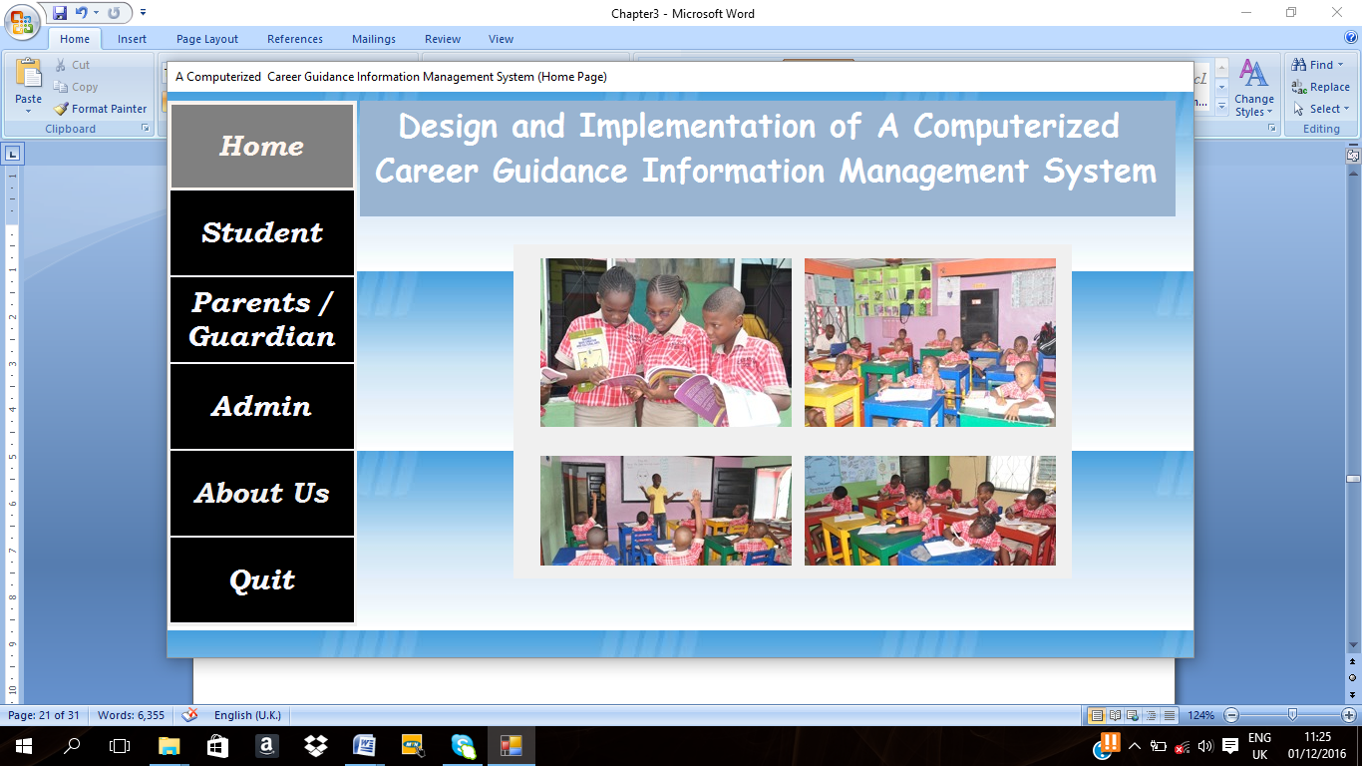

Figure 3.1 Homepage window of the developed system

**3.2.2 Student login page**

These environment allow registered student to login into system to perform a counselling with their username and password as shown in figure 3.2

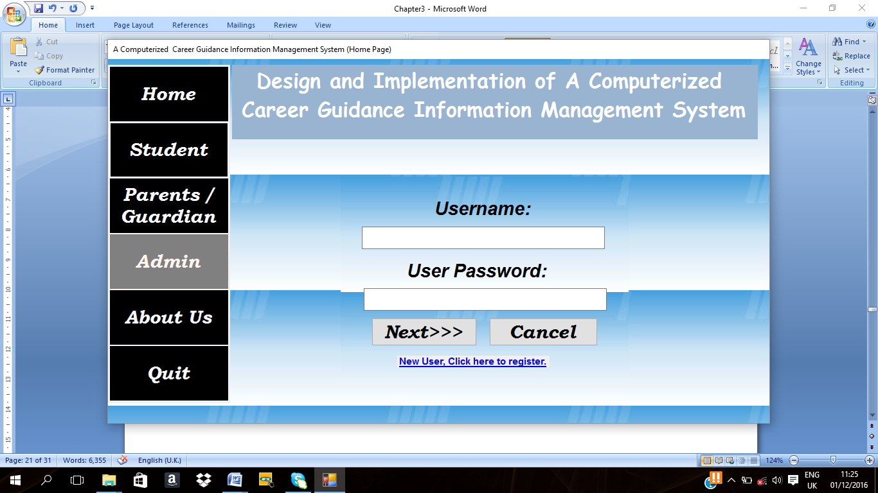

Figure 3.2 Student login page

**3.2.3 Registration page**

These page allows unregistered student to create their username and password before they can gain access to the system shown in figure 3.3

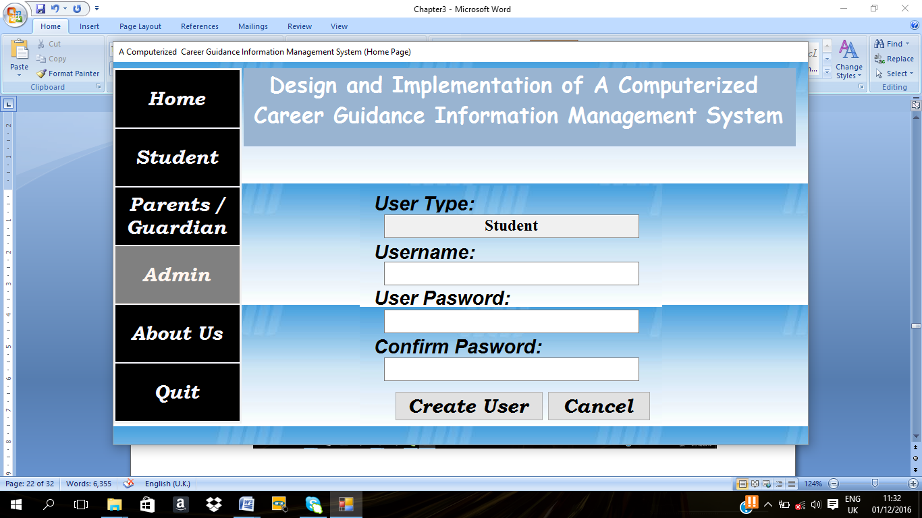

Figure3.3 Registration page

**3.2.4 Data page**

This page allow the student to fill their detail in the system as shown in figure 3.4

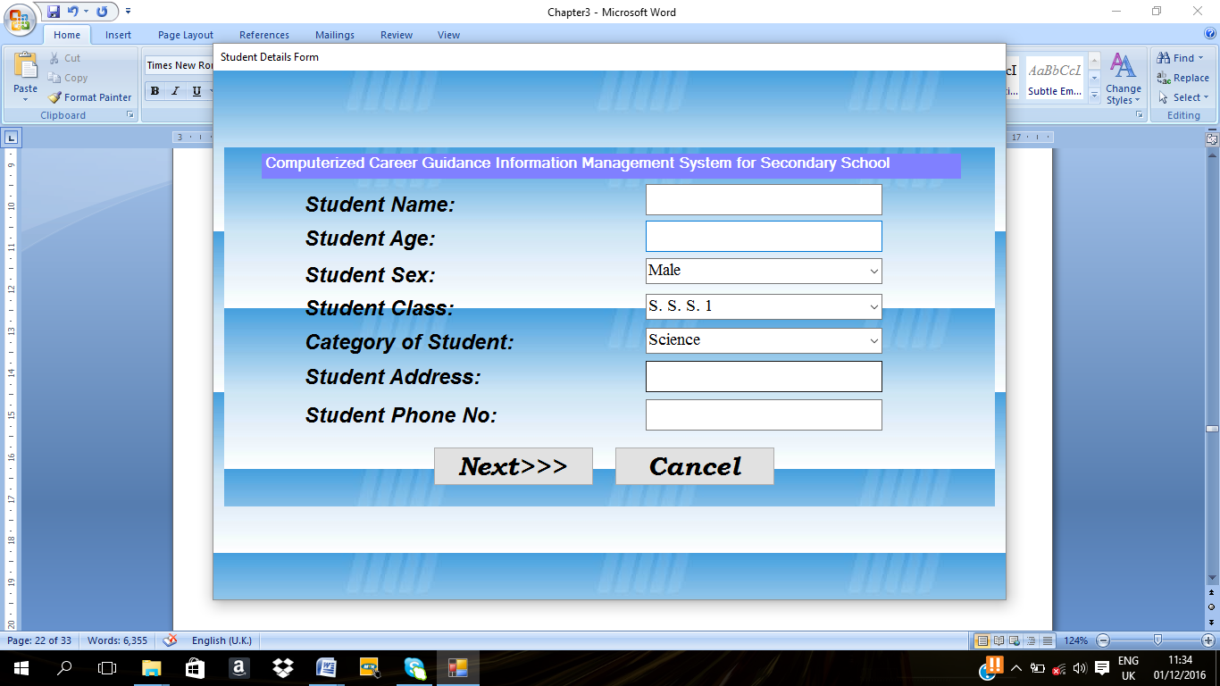Figure3.4 Data page

**3.2.5 Career related question page**

These page enable the student to select a career choice, answer a few question and supply relative subject to the career chosen with their grades, press enter to next page as shown in figure 3.5

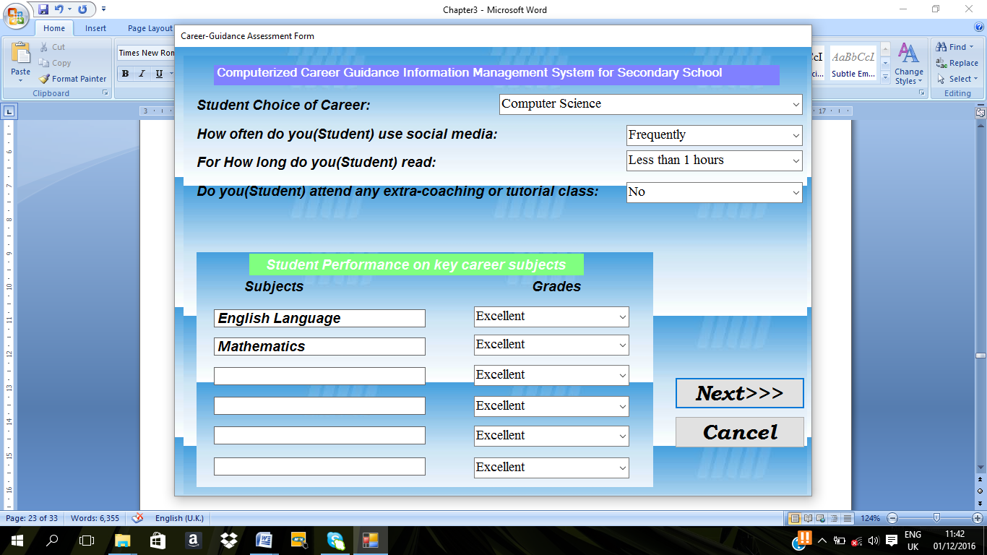

Figure 3.5 Career related question and advice page

**3.2.6 Advice page**

The system generate an advice to the career base on the detail the student suppied in figure3.5 above as shown in figure 3.6

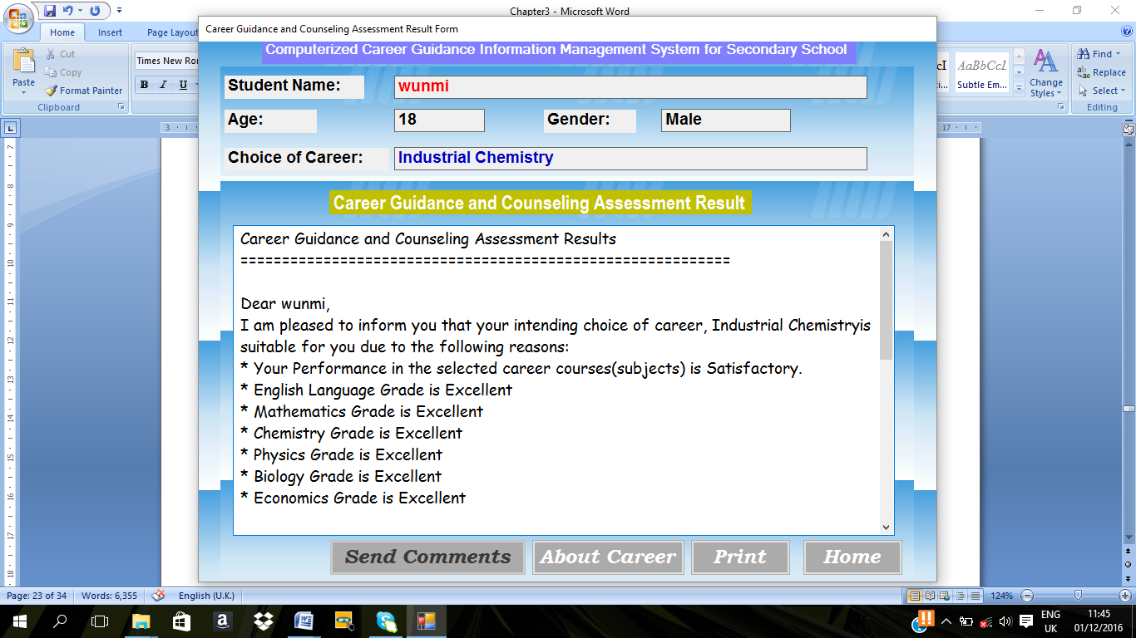

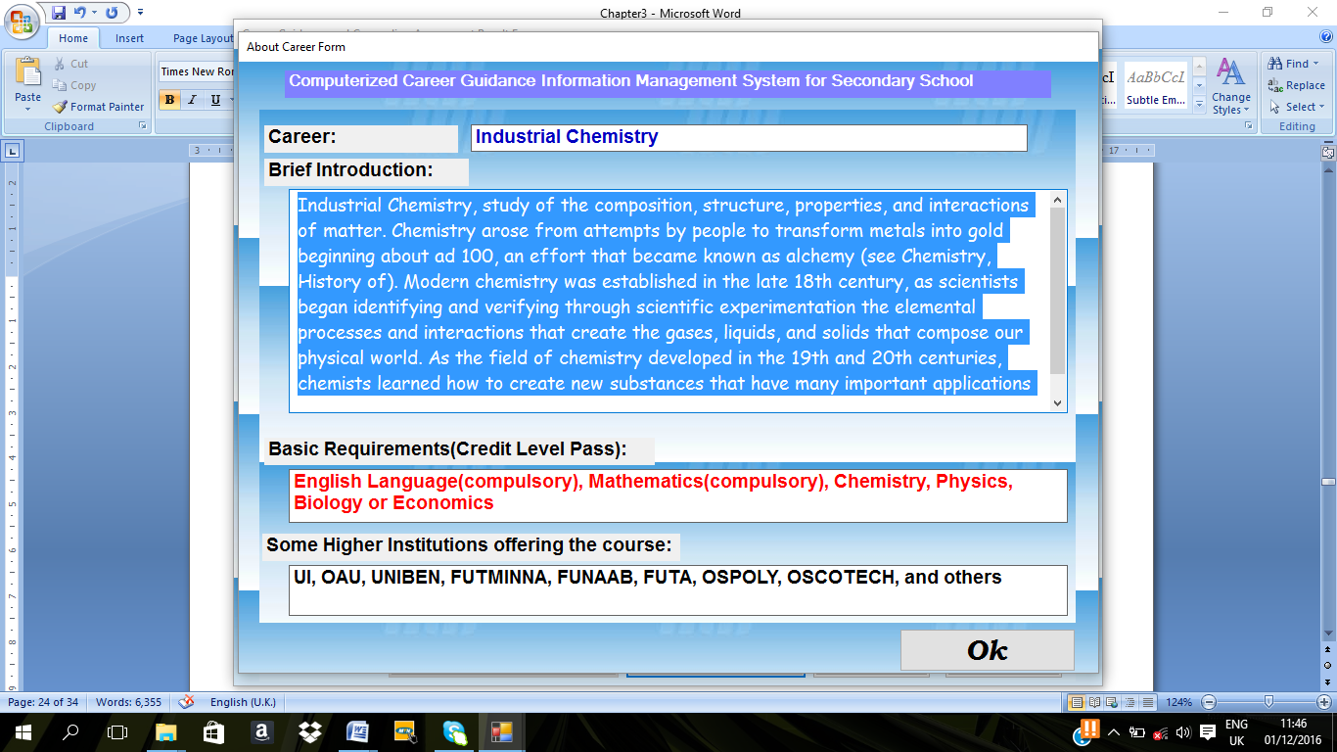

Figure3.6 Advice page

**3.3 System Implementation**

The object oriented paradigm being the natural way of implementing UML design, the implementation of the tool was done using object oriented style. The programming languages of choice were C#.Net and Query language(Ms Access2007),the detailed documentation obtained at the designed stages was translated into classes of the target programming language, an attempt at separation of the graphical user interface(GUI) and the functionality was made.This was to enable the development of a loosely coupled system

**3.4 Evaluation of The Develop System**

Performance evaluation on the develop system was carried out based on criteria. Such as

**3.4.1 Accessibility**

After the system had been tested, the result shows that the new developed system is accessible i.e. the new developed system was available at any convenient time of the users and responsiveness, user can access it anytime they need it or fill like using the new developed system.

**3.4.2 Usability**

From the test and the result generated shows that the new developed system performs all the necessary things it supposes to perform and it does not keep the user wait. The test performed shows that the efficiency and effectiveness of the new developed system is very easy to use, user friendliness and fast in operation.

**3.4.3 Evaluation Methodology**

The developed system was evaluated by Administer questionnaire on (20) users, the completed questionnaire were collected and analysed.

**CHAPTER FOUR**

1. **Result And Discussion**

**4.1 Result**

The result evaluation of the developed system is presented in table 4.1, and 4.2 and figures 4.1, and 4.2

**Table 4.1.** The table of responses from users on usability of the system.

|  |  |  |
| --- | --- | --- |
| The designed system is easy to use | Frequency (users) | Percentage |
| Strongly Agree | 15 | 75% |
| Agreed | 3 | 15% |
| Disagreed | 2 | 10% |
| Strongly Disagree | 0 | 0% |
| Total | 20 | 100 |

Figure.4.1 Graphical Representation of the responses of the users on usability

**Table 4.2.** The table of responses from the users on accessibility of the system

|  |  |  |
| --- | --- | --- |
| The designed system is easy to access | Frequency (users) | Percentage |
| Strongly Agree | 15 | 75% |
| Agreed | 3 | 15% |
| Disagreed | 1 | 10% |
| Strongly Disagree | 0 | 0% |
| Total | 20 | 100 |

Figure .4.2. Graphical Representation of the responses of the users on accessibility

4.2 **Discussion**

Table 4.1 and figure 4.1 shows that 18 users agreed that the developed system is easily accessible..

Table 4.2 and figure 4.2 shows those 18 users out of 20 while only 1users disagreed.

The result presented in table showed that: From the result it is shown that a very high percentage (95%) of the users of the developed system agreed that the system is user friendly and easily accessible.

**CHAPTER FIVE**

**5.0 CONCLUSION AND RECOMMENDATION**

**5.I CONCLUSION**

In this project, a Computerised career information management system was designed and implemented using CN.Net and Quary language (Ms Access) with Microsoft visual studio 2010 and Window operating system. The developed system was also evaluated based accessibility and usability.

From the result generated shown that the developed system was adjusted to be accessible and efficient. It is then concluded that the objective of the study were achieved and the system developed is capable of counselling student efficiently on their career in the absence of the counsellor.

**5.2** **Recommendation**

It is recommended that secondary school student, undergraduate student are adequately trained on the use of the Computerised career information management system. Computer literacy program should be organized for the students at various level. This can be carried out set by set. At the end of the training, it is recommended that the new system is to used to counsel student in secondary school at various level from JSS3 to SSS3.

**REFERENCES**

Bhuiyan, M.S.H. (2011) “Public Sector eService Development in Bangladesh Status Prospects and Challenges” Electronic Journal of e Government 9(1) 15-29.

Bysshe, S., Hughes, D., & Bowes, L. (2002). The economic benefits of career guidance: a review of current evidence. Centre for Guidance Studies, University of Derby.

Euvrard G 1996. Career needs of the eastern cape pupils in South Africa. British Journal of Guidance and Counselling, 24: 113-118.

Harthony, M.G.(1990). Mini and Macro Computer Systems, London; ELBS // Macmillian.

Herr,E.L.,Cramer,S.H.,& Niles,S.G.(1996).Career guidance and counseling through the life span: Systematic approaches(6th ed.).Boston:Pearson Education,Inc.

Killeen, J., White, M., & Watts, A. G. (1992). The economic value of careers guidance (No. 702). London: Policy Studies Institute.

Makura AH, Skead M, Nhundu K 2011. Academic Development Practices at Fort Hare University: An Epitome of University Access. Research in Higher Education Journal. From <http://www.aabri.com/ manuscripts/11797.pdf> (Retrieved on 15 May, 2012).

Olorunsola and Ekong (2006) Computer Aided Designed in Bandele, Olorunsola, Okunade and Ibijola in Information and Communication Technology and Computer Application Ado-Ekiti: General Studies Units. University of Ado-Ekiti.

Osipow S 1968. Theories of Career Development. New York: Meredith Corporation.

Perry, J. C., Liu, X., & Pabian, Y. (2010). School engagement as a mediator of academic performance among urban youth: The role of career preparation, parental career support, and teacher support. The Counseling Psychologist,38(2), 269-295.

Roe,A.(1956).The psychology of occupations.New York:Wiley.

Sampson JP, Peterson GW, Reardon RC, Lenz JG 2010. Bibliography: A Cognitive Information Processing (CIP) Approach to Career Development and Services. From <http://www.career.fsu.edu/documents/cognitive/.

Van Schalkwyk,S.C(2007) Crossing discourse boundries-student diverse realities when negotiating entry into knowledge communities.South Africa journal of Higher Education,21,596-609.

Watts, A. G. (1977). Careers education in higher education: principles and practice. British Journal of Guidance and Counselling, 5(2), 167-184.

Watts, A. G., & Fretwell, D. H. (2004).Public Policies for Career Development. Case Studies And Emerging Issues For Designing Career Information And Guidance Systems In Developing And Transition Economies. World Bank Education Advisory Service.

Zunker,V.G.(2002).Career counseling: Applied concepts of life planning.(6th ed.).Paciﬁc Grove,CA:Brooks/Cole.

information/processing/CIPBIB.doc> (Retrieved on 28 May 2011).